Project Report
Heritage Treasures: An In-Depth Analysis of UNESCO World Heritage Sites in Tableau
1. Introduction
1.1 Project Overview
The Heritage Treasures: An In-Depth Analysis of UNESCO World Heritage Sites in Tableau project is a data visualization and analytics solution developed to explore UNESCO World Heritage Sites using interactive dashboards and stories. The project utilizes the UNESCO World Heritage dataset to analyse heritage sites based on region, country, category, inscription year, endangered status, and geographical area. Data preprocessing techniques such as handling missing values, removing duplicates, and transforming data were performed before visualization.
The project was developed using Python for data preparation, Tableau Desktop for creating dashboards and stories, Tableau Public for publishing visualizations, and Flask for integrating the published dashboards into a web application. Interactive charts, maps, filters, KPIs, and forecasting techniques help users gain meaningful insights into global heritage distribution and conservation trends.
1.2 Purpose
The primary purpose of this project is to provide an interactive platform for analyzing UNESCO World Heritage Sites through effective data visualization and storytelling. The project enables users to explore heritage site distribution across different regions, identify endangered heritage sites, analyse inscription trends over time, and compare heritage categories using interactive dashboards.
It aims to simplify complex heritage data into meaningful visual insights that support research, education, tourism planning, and heritage conservation. By integrating Tableau visualizations into a Flask-based web application, the project offers an accessible and user-friendly interface for exploring UNESCO World Heritage information and promoting awareness of global cultural and natural heritage.

2. Ideation Phase
2.1 Problem Statement
The Define Problem Statements phase focused on identifying the key challenges faced by users of UNESCO World Heritage data. Through a customer-centric approach, two primary user groups were identified: heritage conservation researchers and tourism policy planners. Their major difficulties included fragmented data sources, lack of interactive visual analysis, and challenges in comparing heritage trends across regions and time. These problem statements helped establish a clear understanding of user needs and served as the foundation for designing an interactive Tableau-based analytics solution that simplifies data exploration, supports informed decision-making, and improves access to UNESCO World Heritage insights.
2.2 Empathy Map Canvas
The Empathy Map Canvas was developed to better understand the needs, thoughts, behaviours, and challenges of the target users, including heritage researchers, tourism planners, students, and data enthusiasts. It identified what users think, feel, see, hear, say, and do while working with UNESCO World Heritage data, along with their pain points and expected gains. This exercise provided valuable insights into user expectations and helped design an interactive Tableau-based solution that simplifies heritage data analysis, improves accessibility, and supports informed decision-making through meaningful visualizations and storytelling.
2.3 Brainstorming
The Brainstorming and Idea Prioritization phase focused on generating and evaluating potential solutions for analysing UNESCO World Heritage Sites. Team members collaborated to identify multiple ideas, including interactive dashboards, regional comparisons, endangered site analysis, heritage category visualization, forecasting, and storytelling. These ideas were grouped based on their objectives and prioritized according to their feasibility, impact, and relevance to user needs. The outcome of this phase helped identify the most effective features to be implemented in the project, resulting in a comprehensive Tableau-based solution for interactive heritage data analysis and visualization.

3. Requirement Analysis
3.1 Customer Journey Map
The Customer Journey Map illustrates the complete journey of users while interacting with the UNESCO World Heritage Sites Analysis system. It captures each stage, from discovering the need for heritage information to exploring interactive dashboards, analysing heritage trends, and obtaining meaningful insights. The map highlights user goals, activities, pain points, and opportunities for improvement at every stage. This analysis helped design a user-friendly solution that enhances data accessibility, supports interactive exploration, and provides valuable insights into UNESCO World Heritage Sites through Tableau dashboards and stories.
3.2 Solution Requirement
The Solution Requirements phase defined the functional and non-functional requirements for the UNESCO World Heritage Sites Analysis project. The functional requirements covered key project activities, including data collection, data preparation, interactive visualization development, dashboard and story creation, Flask-based website integration, user interaction, and analytical reporting. The non-functional requirements focused on ensuring usability, performance, reliability, availability, scalability, and security of the application. These requirements served as the foundation for designing a robust, interactive, and user-friendly system that effectively supports the analysis and visualization of UNESCO World Heritage Sites.
3.3 Data Flow Diagram
The Data Flow Diagram (DFD) and User Stories phase defined the overall system workflow and functional requirements of the UNESCO World Heritage Sites Analysis project. The Data Flow Diagram illustrates how data moves through the system, from data collection and preprocessing to visualization, dashboard creation, and web deployment. The User Stories describe the project features from the users' perspective, covering activities such as data preparation, interactive visualization, dashboard and story development, website integration, and navigation. Together, they provided a structured development roadmap that ensured the system met user requirements and delivered an efficient, interactive, and user-friendly analytical solution.
3.4 Technology Stack
The Technology Stack phase defined the architecture and technologies used to develop the UNESCO World Heritage Sites Analysis project. It outlines the interaction between the user interface, application logic, data storage, visualization tools, and deployment components. The project utilizes Python for data preprocessing, Tableau Desktop for creating interactive dashboards and stories, Tableau Public for publishing visualizations, and Flask for web integration. The architecture ensures efficient data processing, interactive visualization, secure access, scalability, and smooth user interaction, providing a reliable platform for analysing UNESCO World Heritage Sites.

4. Project Design
4.1 Problem Solution Fit
The Problem–Solution Fit phase focused on ensuring that the proposed solution effectively addresses the challenges faced by users in analysing UNESCO World Heritage Sites. It examined user problems, behaviours, needs, and expectations, and aligned them with appropriate features such as interactive dashboards, visual analytics, storytelling, and web integration. This phase validated that the project delivers meaningful insights through an intuitive and user-friendly platform, enabling researchers, students, tourism planners, and heritage enthusiasts to efficiently explore and analyse UNESCO World Heritage data.
4.2 Proposed Solution
The Proposed Solution phase defines the overall approach adopted to address the challenges associated with analysing UNESCO World Heritage data. It presents an interactive analytics platform that combines data preprocessing, Tableau dashboards, storytelling, and a Flask-based web application to transform complex heritage data into meaningful visual insights. The solution emphasizes usability, scalability, and accessibility while supporting heritage conservation, tourism planning, education, and research. By integrating interactive visualizations with a user-friendly interface, the proposed solution enables users to efficiently explore UNESCO World Heritage Sites and make informed, data-driven decisions.

4.3 Solution Architecture
The Solution Architecture phase defines the overall structure and workflow of the UNESCO World Heritage Sites Analysis project. It illustrates how the UNESCO dataset is collected, pre-processed, visualized using Tableau, and integrated into a Flask-based web application for user access. The architecture establishes the interaction between data sources, processing components, visualization tools, and the user interface, ensuring efficient data flow and seamless communication across the system. This structured design provides a scalable, reliable, and user-friendly solution for exploring and analysing UNESCO World Heritage Sites through interactive dashboards and stories.

5. Project Planning & Scheduling
5.1 Project Planning
The Project Planning phase organized the development of the UNESCO World Heritage Sites Analysis project using an Agile approach. The project work was divided into user stories, epics, and two planned sprints covering data collection, data preparation, visualization development, dashboard creation, and story development. Story points were assigned to estimate the effort required for each task, while sprint planning, velocity calculation, and the burndown chart were used to monitor progress and ensure timely completion. This structured planning approach enabled efficient task management, effective team coordination, and successful project execution.

6. Functional and Performance Testing
6.1 Performance Testing
The Performance Testing phase evaluated the functionality and performance of the UNESCO World Heritage Sites Analysis project after development. The testing confirmed that the dataset was successfully processed, data preprocessing operations were completed accurately, and calculated fields were implemented correctly. Interactive filters, visualizations, dashboards, and story points were tested to ensure they functioned as expected and provided accurate analytical insights. The successful execution of these tests demonstrated that the application is reliable, responsive, and capable of delivering an efficient and user-friendly experience for exploring UNESCO World Heritage data.

7. Results
7.1 Output Screenshots
1. Home Page of the UNESCO World Heritage Sites Analysis Website
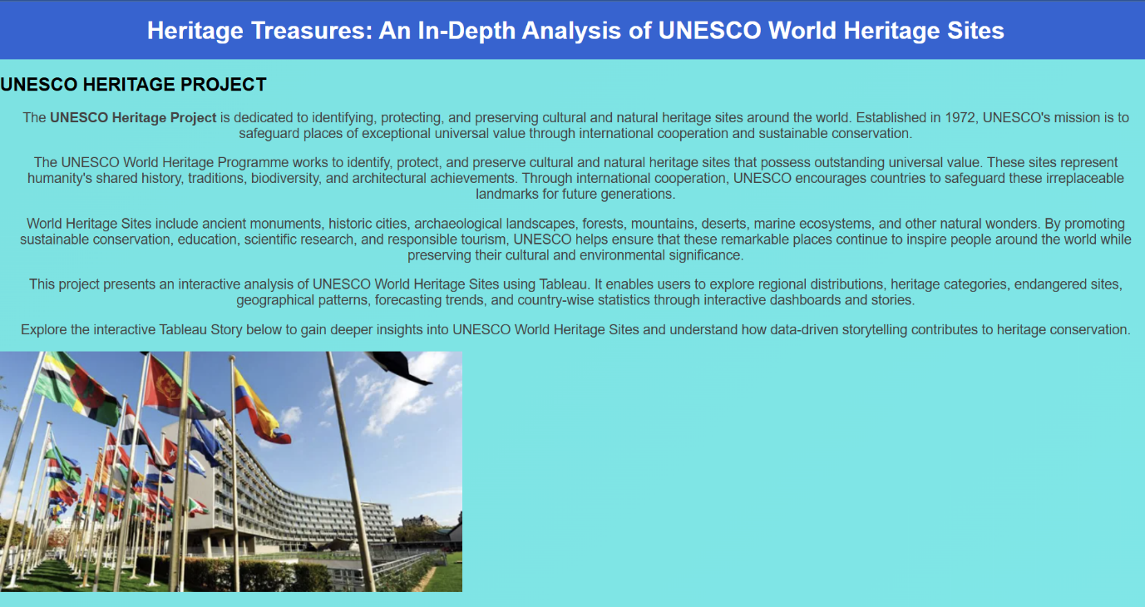
The home page provides an introduction to the project and allows users to navigate to the Tableau dashboards and stories. It presents the project objectives and offers an intuitive interface for exploring UNESCO World Heritage data.
2. UNESCO World Heritage Sites Overview Dashboard
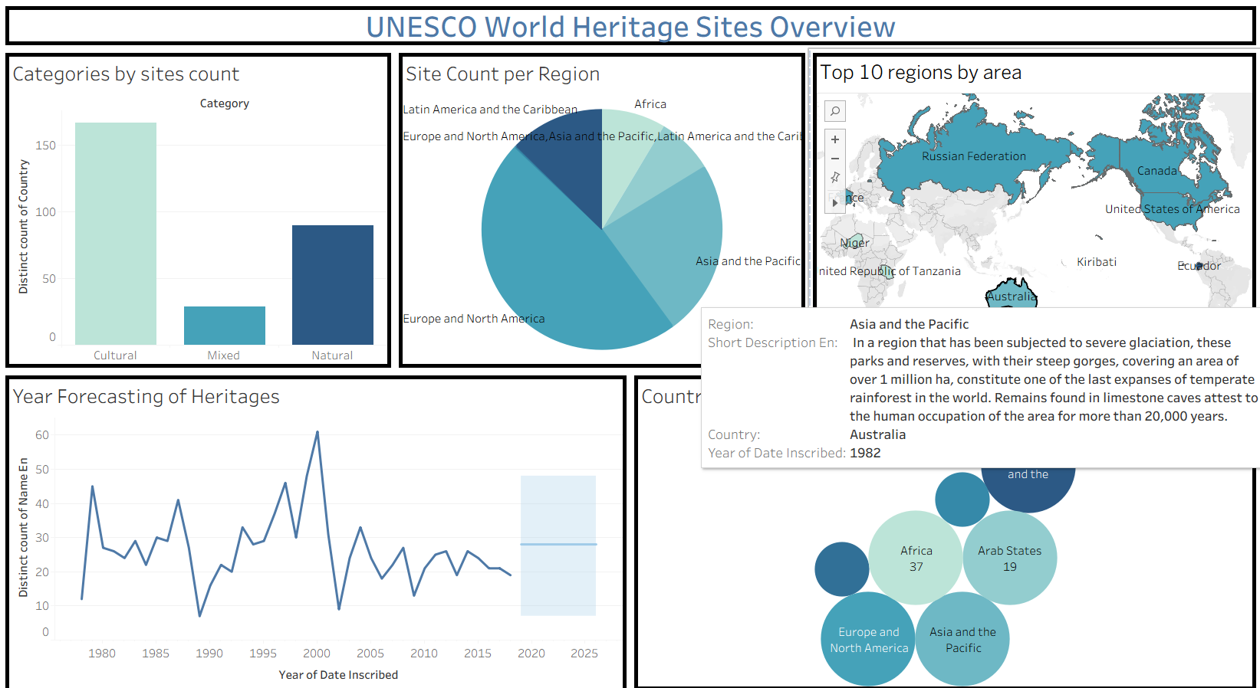This dashboard presents an interactive overview of UNESCO World Heritage Sites through charts, maps, and KPIs. Users can analyse regional distribution, heritage categories, endangered sites, and inscription trends using interactive filters.
3. UNESCO Danger Sites Overview Dashboard
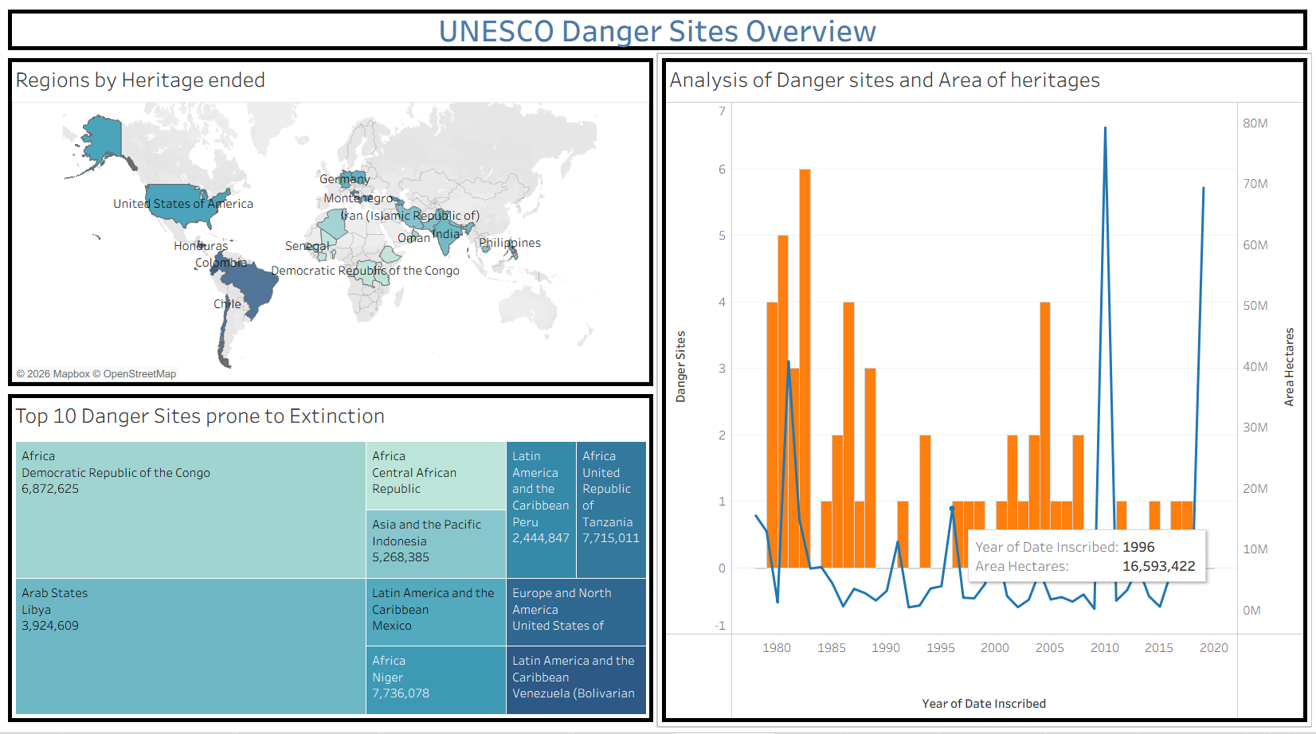
This dashboard focuses on endangered UNESCO World Heritage Sites by highlighting at-risk locations, heritage area comparisons, and regional statistics. It helps users identify conservation priorities through interactive visualizations.
4. UNESCO World Heritage Sites Story
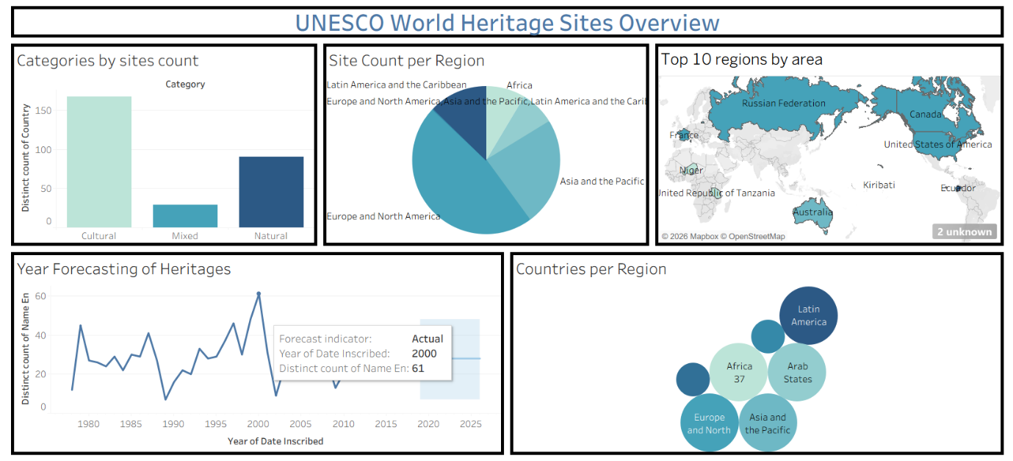
The Tableau Story combines multiple dashboards into a sequential presentation, enabling users to understand heritage distribution, regional comparisons, endangered sites, and historical trends through data storytelling.

8. Advantages & Disadvantages
Advantages | Disadvantages
Interactive dashboards and visualizations make UNESCO heritage data easy to understand. | The quality of analysis depends on the accuracy and completeness of the UNESCO dataset.
Enables efficient analysis of heritage distribution, categories, endangered sites, and historical trends. | Published Tableau dashboards require an internet connection for online access.
Provides a simple and user-friendly web interface for easy navigation. | The project currently uses a static dataset and does not automatically update with new UNESCO data.
The solution is scalable and can be extended with additional datasets, cloud deployment, and advanced analytics. | The project relies on Tableau and Flask technologies, requiring familiarity with these tools for future enhancements.
Supports researchers, students, tourism planners, and policymakers in making informed decisions. | Limited to visualization and basic forecasting without advanced AI or machine learning capabilities.
Interactive filters allow users to explore data by region, country, category, and inscription year. | Dashboard performance may decrease when working with significantly larger datasets.
Tableau forecasting helps identify future heritage inscription trends. | The application does not support user authentication or personalized user features.
Promotes awareness of cultural and natural heritage through interactive storytelling. | Customization and editing of the underlying dataset are not available through the web interface.

9. Conclusion
The Heritage Treasures: An In-Depth Analysis of UNESCO World Heritage Sites in Tableau project successfully transformed complex UNESCO World Heritage data into meaningful and interactive visualizations. By integrating Python for data preprocessing, Tableau for dashboard and story creation, and Flask for web integration, the project provides an efficient platform for exploring heritage site distribution, categories, endangered sites, and historical inscription trends.
The developed dashboards and stories enable users to analyse heritage information through interactive charts, maps, filters, and forecasting techniques, making the data more accessible and easier to understand. The project supports researchers, students, tourism planners, educators, and policymakers in gaining valuable insights that contribute to heritage conservation, tourism planning, and informed decision-making.
Overall, the project demonstrates the effectiveness of data visualization and business intelligence tools in converting large datasets into actionable insights. It also provides a scalable foundation for future enhancements, such as real-time data integration, advanced analytics, AI-based recommendations, and cloud deployment, making it a valuable solution for UNESCO World Heritage data analysis.

10. Future Scope
The Heritage Treasures: An In-Depth Analysis of UNESCO World Heritage Sites in Tableau project can be further enhanced by incorporating advanced features and technologies to improve its functionality and user experience. Future improvements may include integrating real-time UNESCO data through APIs to ensure that visualizations are always up to date. The project can also be extended with Artificial Intelligence (AI) and Machine Learning (ML) techniques to predict future heritage trends, identify sites at risk, and provide intelligent recommendations for conservation planning.
Additionally, the application can be deployed on cloud platforms to improve accessibility and support a larger number of users. Mobile-responsive and multilingual versions can be developed to reach a wider global audience. More interactive dashboards, advanced analytics, geospatial visualizations, and personalized user features can also be incorporated. These enhancements will make the platform more comprehensive, scalable, and valuable for researchers, educators, tourism planners, policymakers, and heritage conservation organizations.

11. Appendix
11.1 Source code
The complete source code of the project, including the Flask application, HTML, CSS, JavaScript files, and Tableau integration, is available in the Google drive link provided below.
The source code link = https://drive.google.com/drive/folders/1SXpnThdWDYB22FdTqFe0X6L3ZZUrX5ed?usp=sharing
11.2 Dataset Link
The UNESCO World Heritage Sites dataset used for data preprocessing, visualization, and analysis in this project is available at the following link.
Dataset link = https://www.kaggle.com/datasets/ujwalkandi/unesco-world-heritage-sites/data?select=whc-sites-2019.csv
11.3 Project Demo Link
The project demo showcases the complete working of the Heritage Treasures: An In-Depth Analysis of UNESCO World Heritage Sites in Tableau application. It demonstrates the project's features, including the web interface, interactive Tableau dashboards, story points, data visualizations, and overall system functionality.
Project demo link = https://drive.google.com/file/d/1pUAOwX2ZQNVfUqhDaOMuID2mP8tLvn5-/view?usp=sharing

